# Analyst Hiring Exercise

Thank you for your interest in TNTP. Our organization’s hiring process includes a focus on exercises that are similar to the day-to-day work for the open position. This gives you an opportunity to make a meaningful assessment of how a role will fit you, and allows us to observe your skills first-hand.

The Analyst’s most important responsibilities include drawing lessons from the best available data to inform and advance the organization’s mission of ensuring all students have access to effective teachers. The exercise below is designed to simulate these responsibilities on a small scale. The skills required to do well in this exercise are the same as those our Analysts currently use in our work throughout the country.

There is no one right answer. We are looking for responses that demonstrate efficient and accurate analytical skills, attention to detail, and the ability to communicate effectively, both in words and visuals, to a client.

Please complete the exercise below and submit your work to the Staffing Manager by the given deadline. We value your time and have designed the exercise with that in mind; please spend no more than a few hours on this project.

## Show your work

You may complete this assignment in whatever software you feel is best suited for the task. We are as interested in the way you do your work as we are in the results. Please show all your work in a way that allows us to follow each step of your analysis.

If you use a statistical programming language, submit an annotated script to show and explain your work, including any steps to prepare and analyze the data. Please also submit a copy of your script in PDF (or similar), to avoid any potential difficulty in opening different file formats.

If you complete this project in Excel or similar software, submit a workbook that retains all formulas, cells, or sheets that are helpful in following your work. Please also annotate your workbook to clearly show the steps you took to answer each question.

## Data sources:

**StudentScores.csv**

This file contains aggregated student test results for the 2013-2014 state assessment for all schools in a district, with results broken out by grade and subgroup.

**EducatorEffectivenessSnapshot.csv**

This file contains a summary of teacher effectiveness ratings broken out by school. Teachers are assigned a rating of Highly Effective, Effective, Minimally Effective, or Ineffective based on the district’s teacher evaluation rubric.

These files are subsets of real, publicly available data, and represent the sort of files that the Analyst will interact with in the course of their day-to-day work.

**Business rules to use in analysis:**

* Values of “<10” may be omitted (i.e., treated as NA)
* Ensure that every school on the Student Scores list has a match on the Educator Effectiveness Snapshot list

Exercise:

Part 1: Summarize the Student Scores data to show the percent of students who are proficient or higher in math at each school.

1. Populate a table showing the top ten schools in math proficiency along with their proficiency rates (percent of students scoring at proficient or higher). There should be one percentage per school that accounts for all students at the school.

|  |  |
| --- | --- |
| **School Name** | **% Proficient or Above in Math** |
| Wright, Charles School | 64.15 |
| Chrysler Elementary School | 59.90 |
| Davison Elementary-Middle School | 58.89 |
| Bates Academy | 50.77 |
| Dixon Elementary School | 41.43 |
| Burton International School | 39.96 |
| Pasteur Elementary School | 38.34 |
| Cooke Elementary School | 32.65 |
| Nichols Elementary-Middle School | 29.10 |
| Garvey Academy | 28.28 |

Part 2: Explore the relationship between math proficiency and educator effectiveness at the school level.

* 1. Calculate the correlation between the percent of students at a school who are proficient in math (the result of Part 1) and the percent of educators at a school who are rated Effective or Highly Effective. All schools in the Student Scores file should be used in this correlation.
  2. The client for this work is the district’s Director of School Improvement. Provide the Director with a brief (no more than a paragraph or two) interpretation of the result of this correlation. What did you find? What do you think the district can learn from this result?

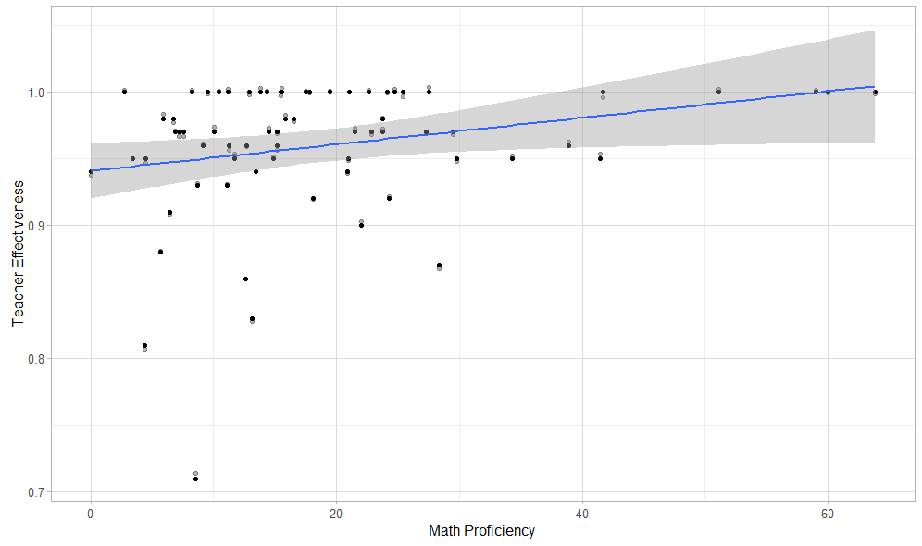

As shown in the graph above, there is a weak to moderate, positive relationship between school proficiency in math and educator effectiveness ratings. Schools with a higher share of teachers rated effective or highly effective also tend to have a higher percentage of students proficient or highly proficient in math. It is exciting to see a relationship between educator effectiveness ratings and student assessment outcomes, but there are some additional factors and pieces of data to consider. Of the 68 schools in the district, 24 rated all educators effective or highly effective. For those 24 schools, there was a wide range of percent of students proficient or above in math (from 2% to 63%). This could mean that other factors, outside of access to effective educators, impact student scores on math assessments. It could also mean that educator effectiveness ratings are inflated, and not all teachers who are receiving effective or highly effective ratings are effective at improving student outcomes.

Part 3: Examine the spread of educator ratings in the district. The district is interested in how the evaluation rating scale has been used in practice.

1. Create a chart illustrating a main message that you see in the ratings data. The audience for this chart is the Director of School Improvement.
2. Provide a short accompanying description for your chart. What trend(s) do you notice and how might they be actionable for the district?

*I included a few different visualizations of the data, as I’m used to clients asking for multiple charts/cuts/views of the data.

|  |  |
| --- | --- |
| **Rating** | **Percent** |
| Highly Effective | 79.00% |
| Effective | 17.00% |
| Minimally Effective | 2.00% |
| Ineffective | 2.00% |

As the charts above detail, nearly 80% of teachers in DCSD are rated highly effective. Of the bottom 10 schools in terms of student proficiency in Math, 5 schools rated over 80% of their teachers highly effective in the 2013-2014 school year. It appears there is a disconnect between student outcomes and teacher ratings—while nearly all teachers are rated effective or highly effective, only 14.7% students in the district were deemed proficient or highly proficient in mathematics in the 2013-2014 school year. Only 4% of teachers in the entire district were rated minimally effective or ineffective, regardless of student proficiency.

I would like to better understand how are ratings are calculated to understand why nearly all teachers rated effective or higher. Does the district believe nearly all of its teachers are effective or highly effective? Are ratings based on classroom observations? Who is conducting the observations and are they given a rubric? Does student performance factor into ratings?

The next step to examine the lack of differentiation in ratings would be to review how the ratings are calculated, as well as if the raters are normed to the ratings model. What is missing from the ratings calculation and how can the district ensure that teachers are receiving accurate feedback on their performance so they may receive the support they need to help improve student outcomes?

I would also recommend analyzing the performance of students and teachers with the biggest disconnect in proficiency and ratings to help the district determine what supports students and teachers need to improve math proficiency and other student outcomes. I could look at schools that have a high share of teachers rated highly effective, yet a lower than average share of students deemed proficient in mathematics. to identify other factors that may be impacting student performance. Are these students coming into their teacher’s classroom not meeting grade level standards (whether from this district or another)? What are students’ perceptions of teacher effectiveness?